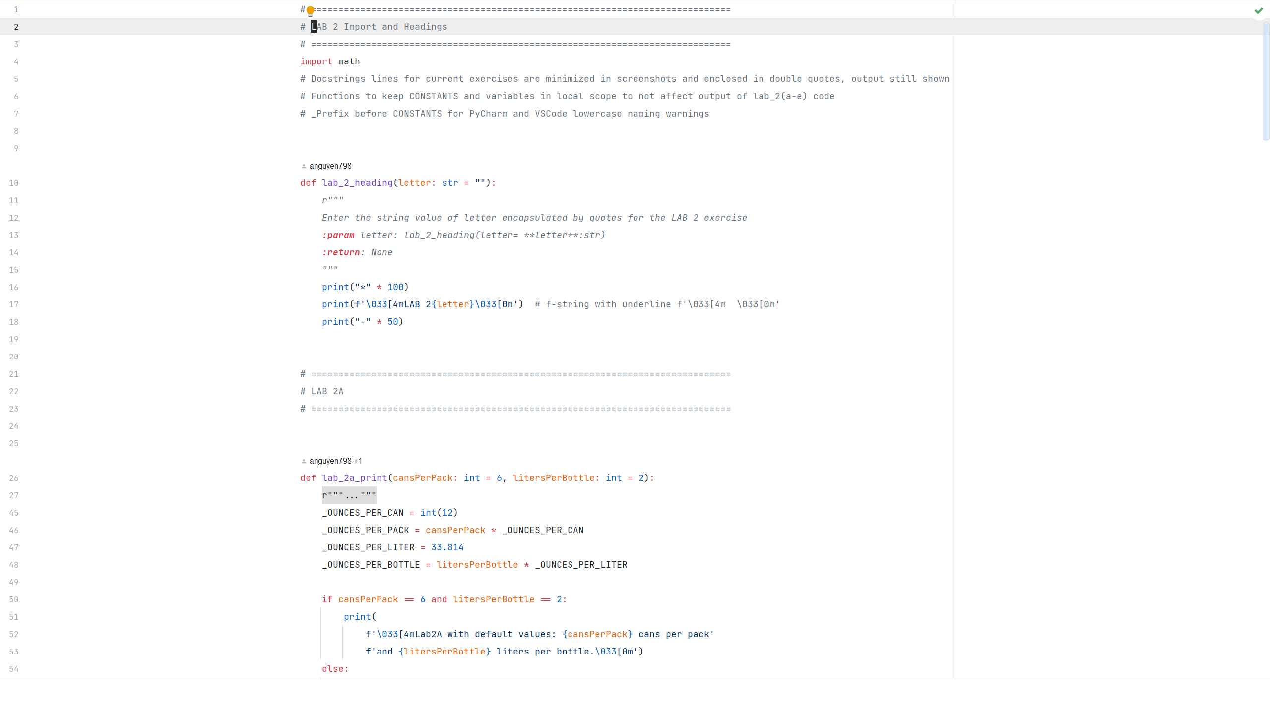

Lab2

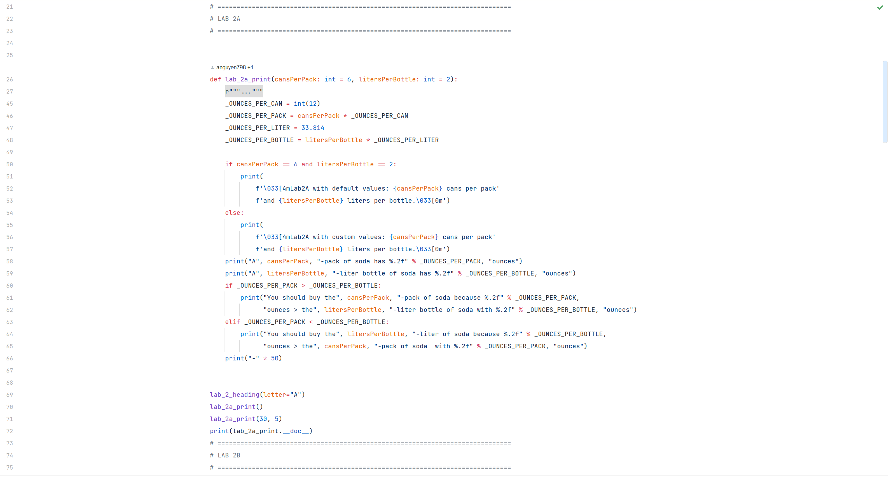

A_Code

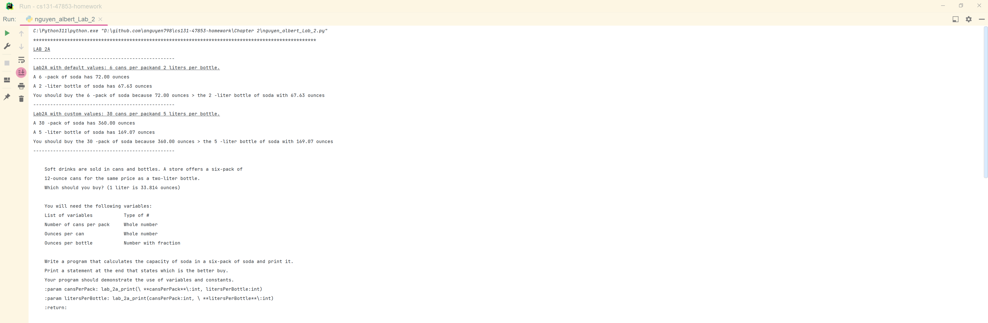

A_Console

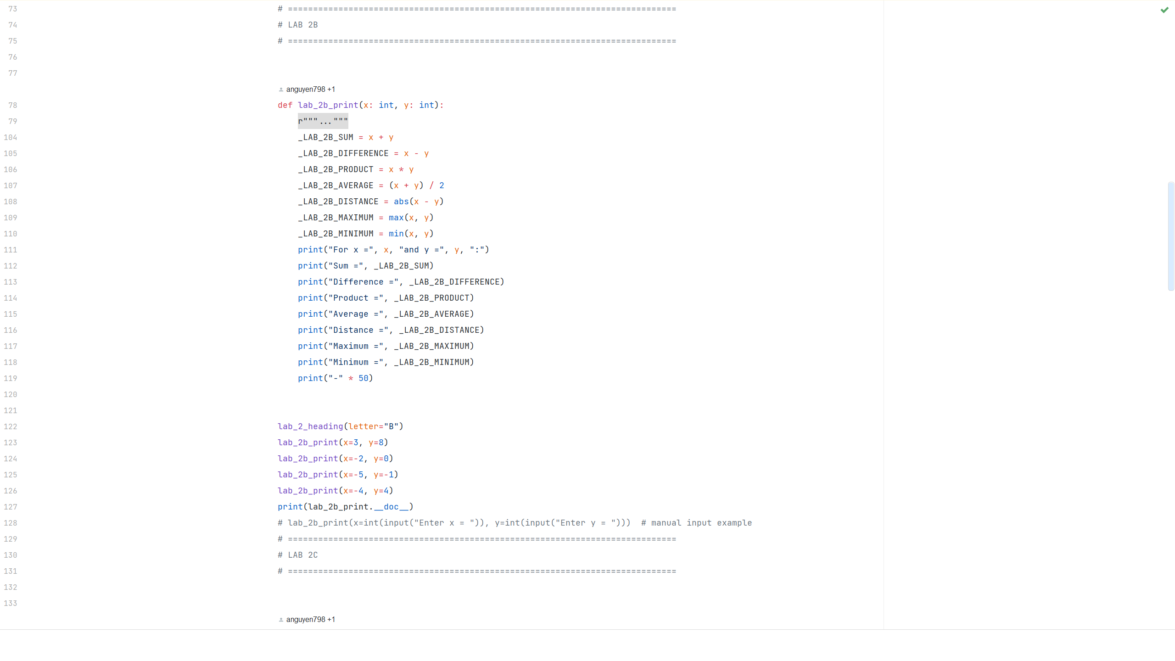

B_Code

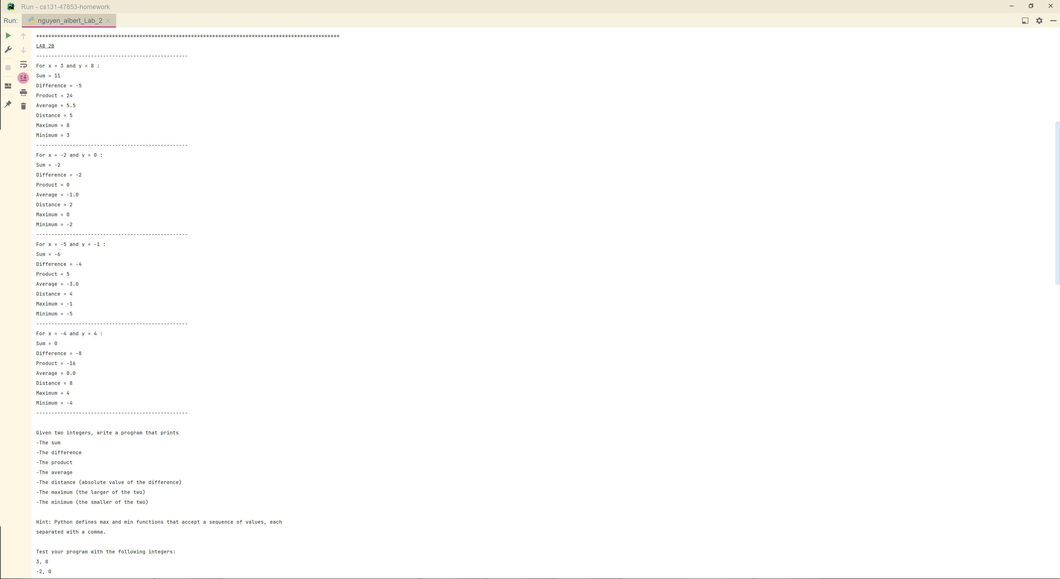
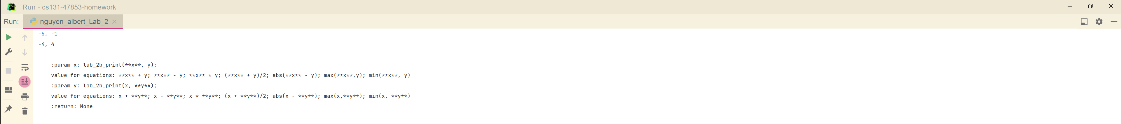
B_Console

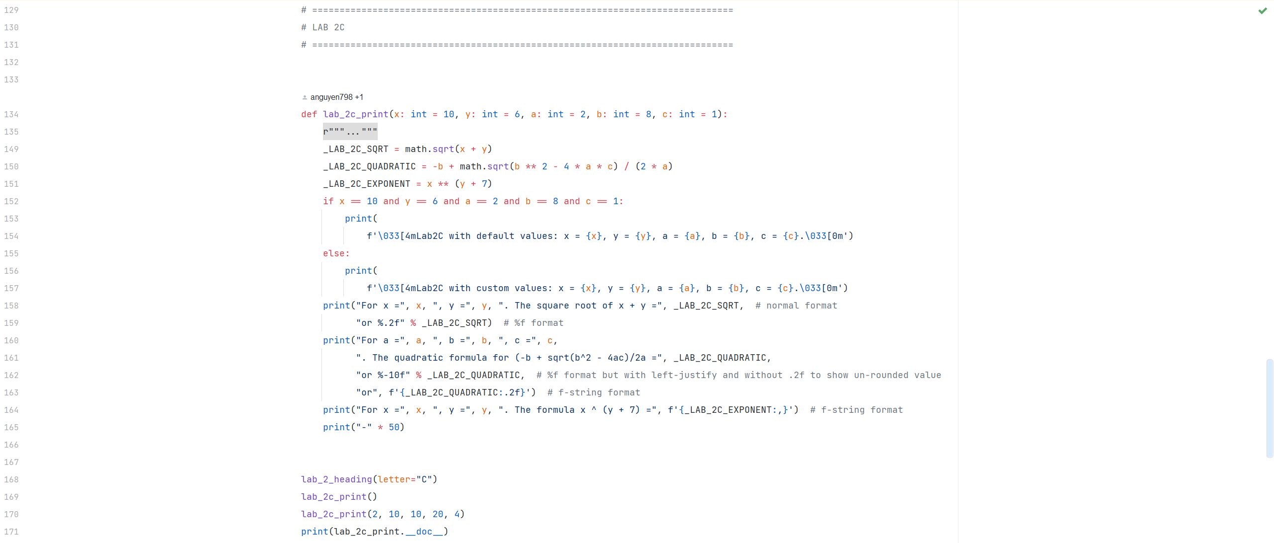

C_Code

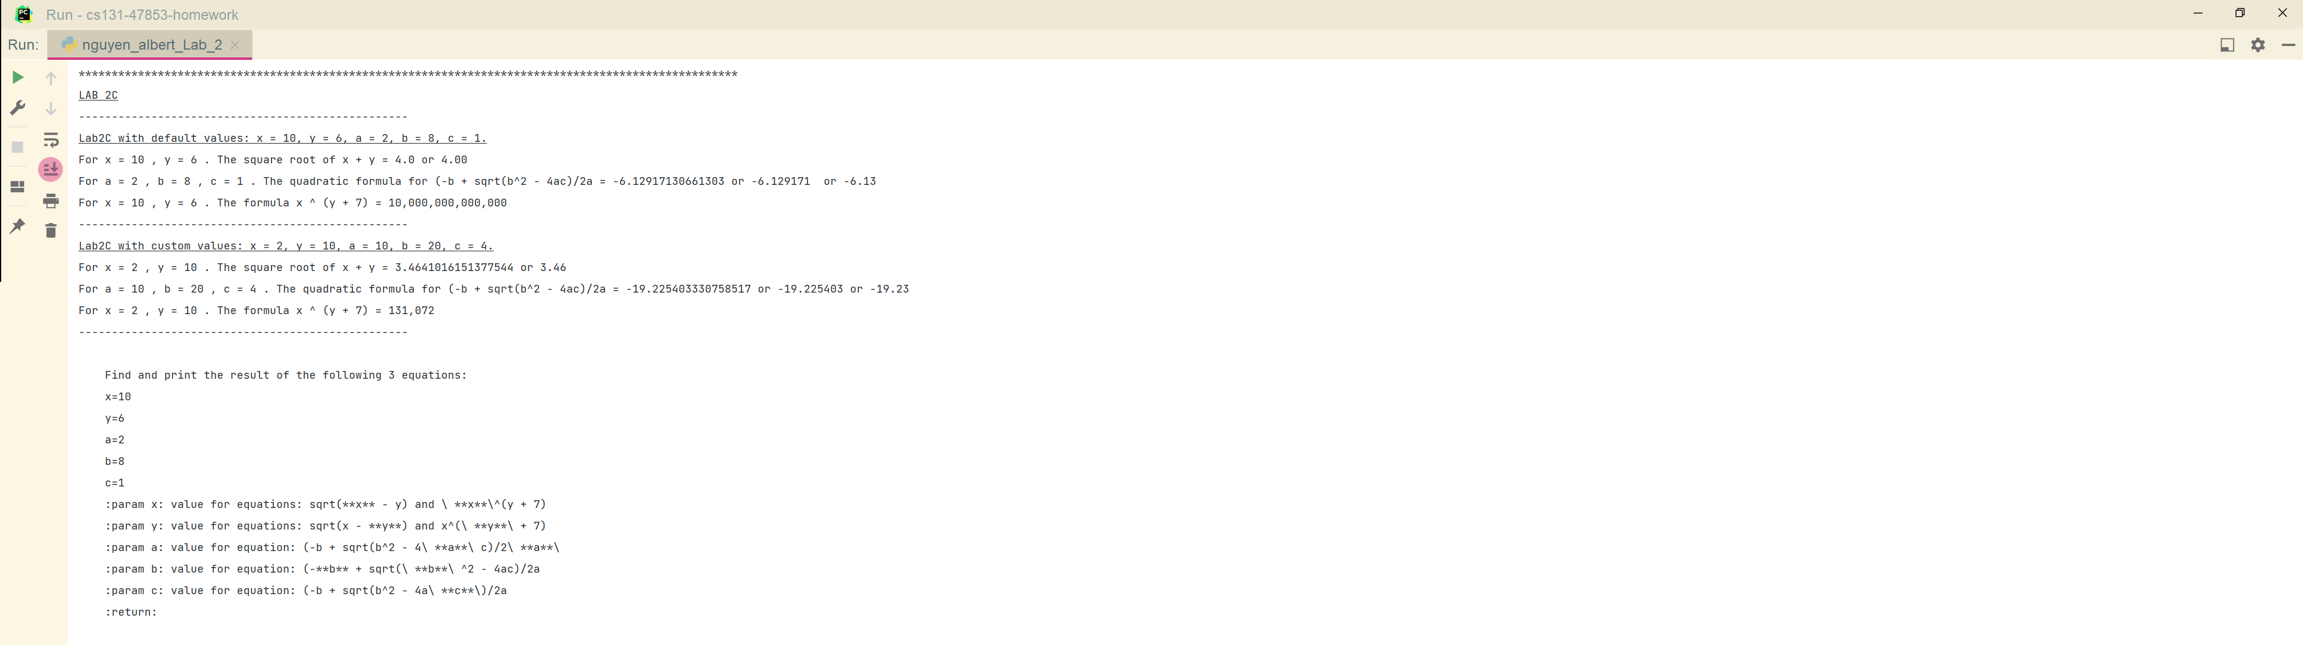
C_Console

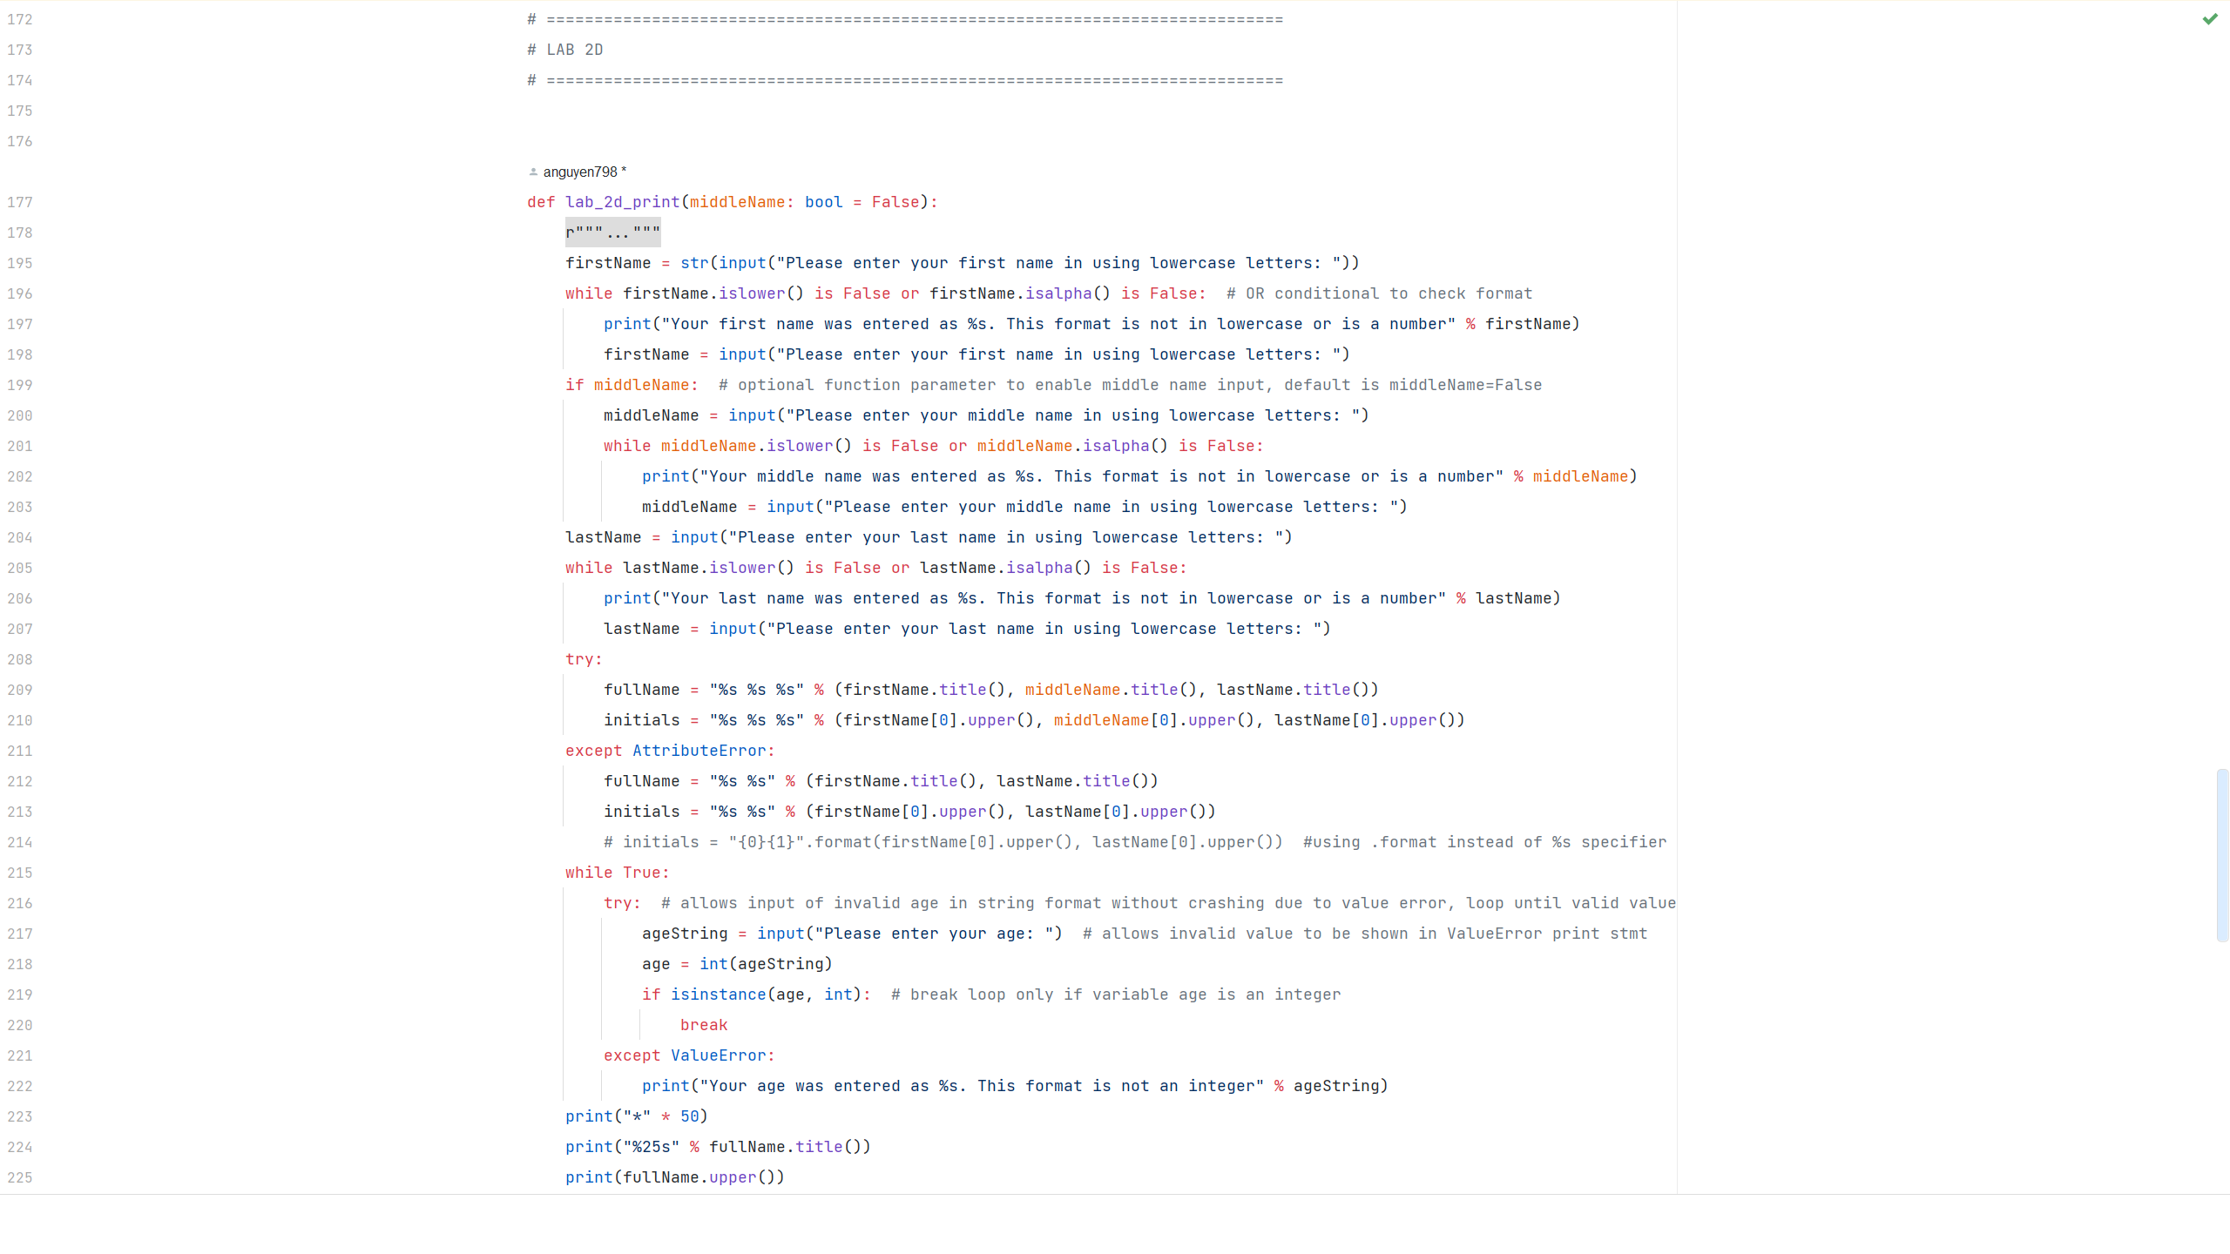
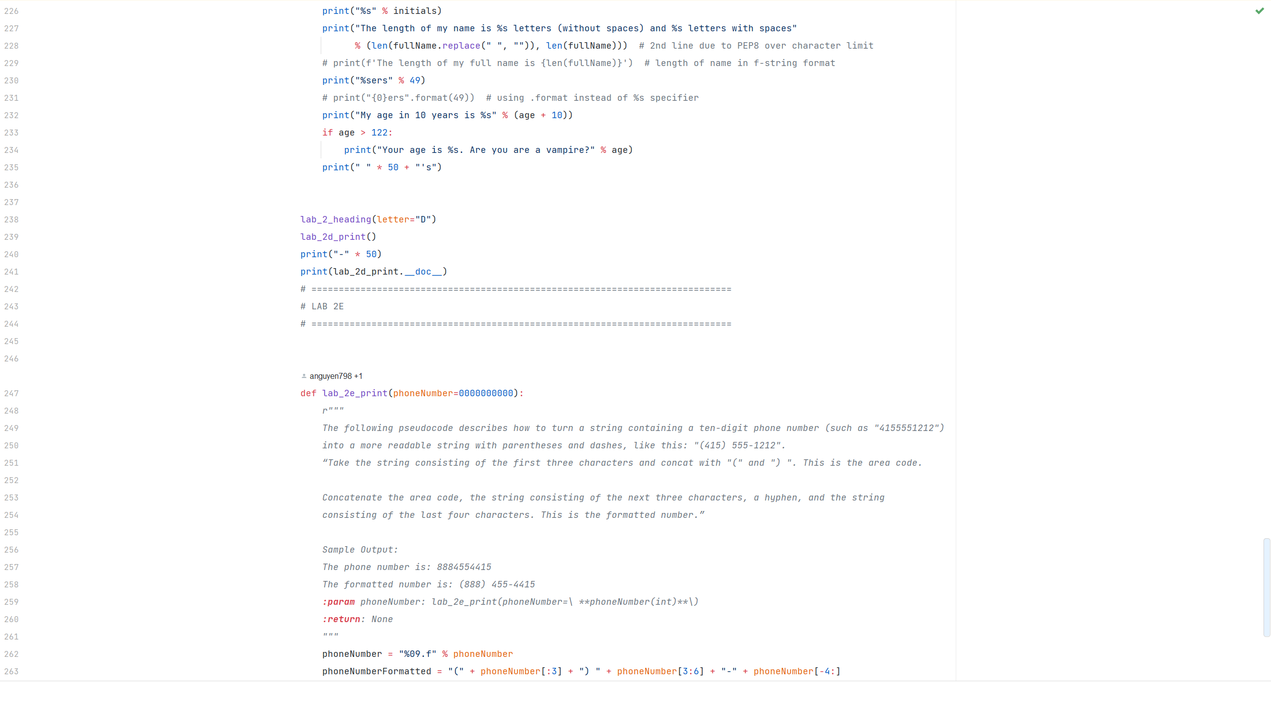
D_Code
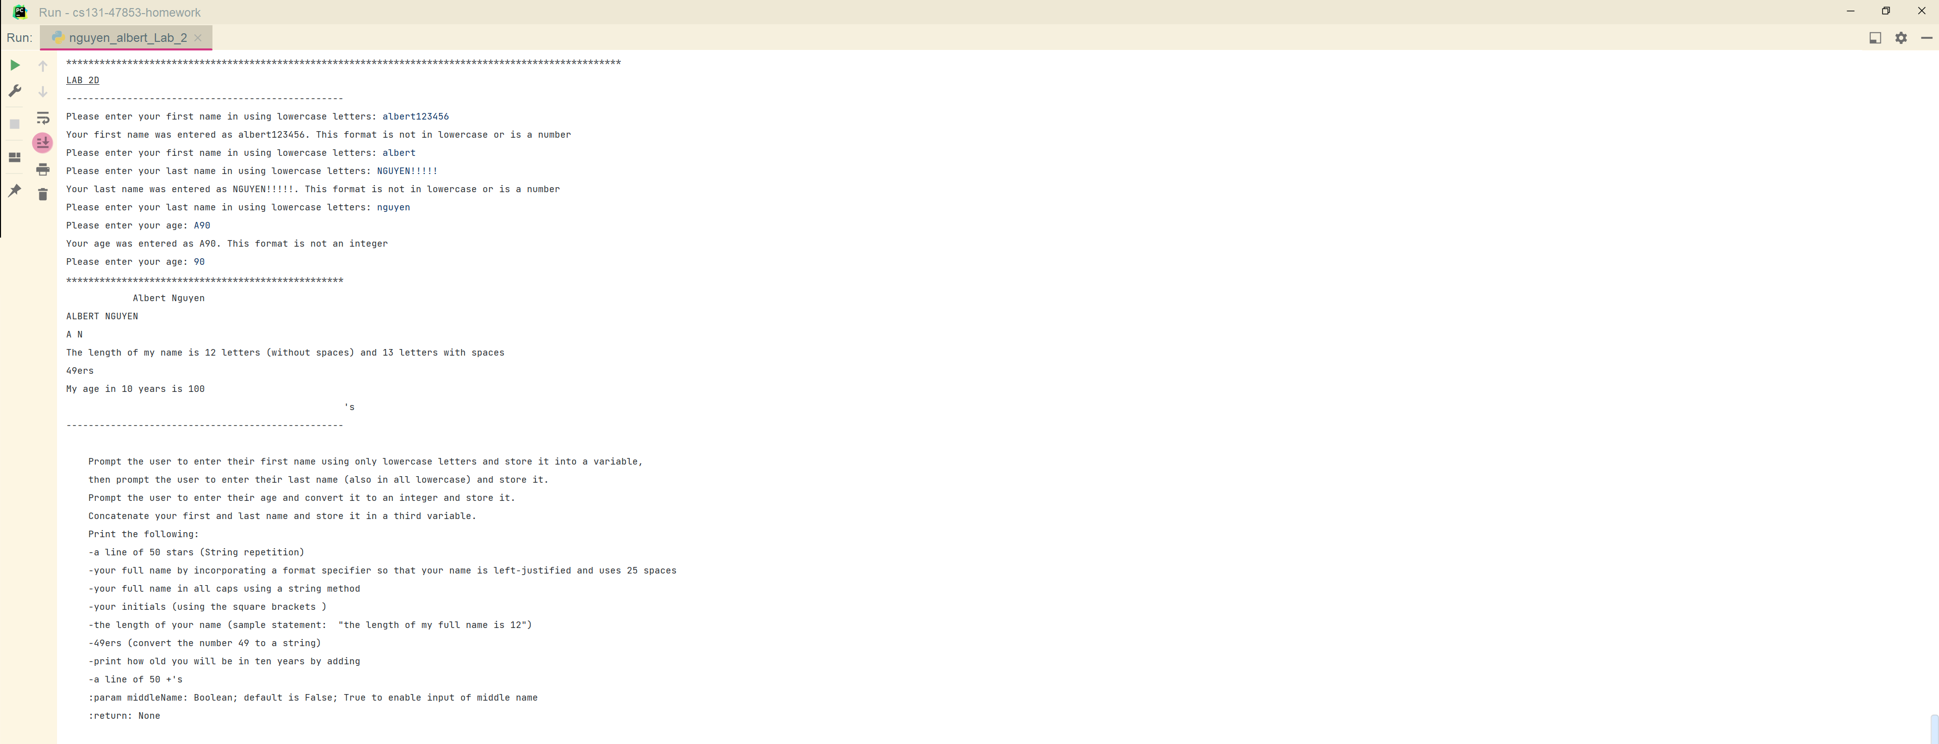

D_Console

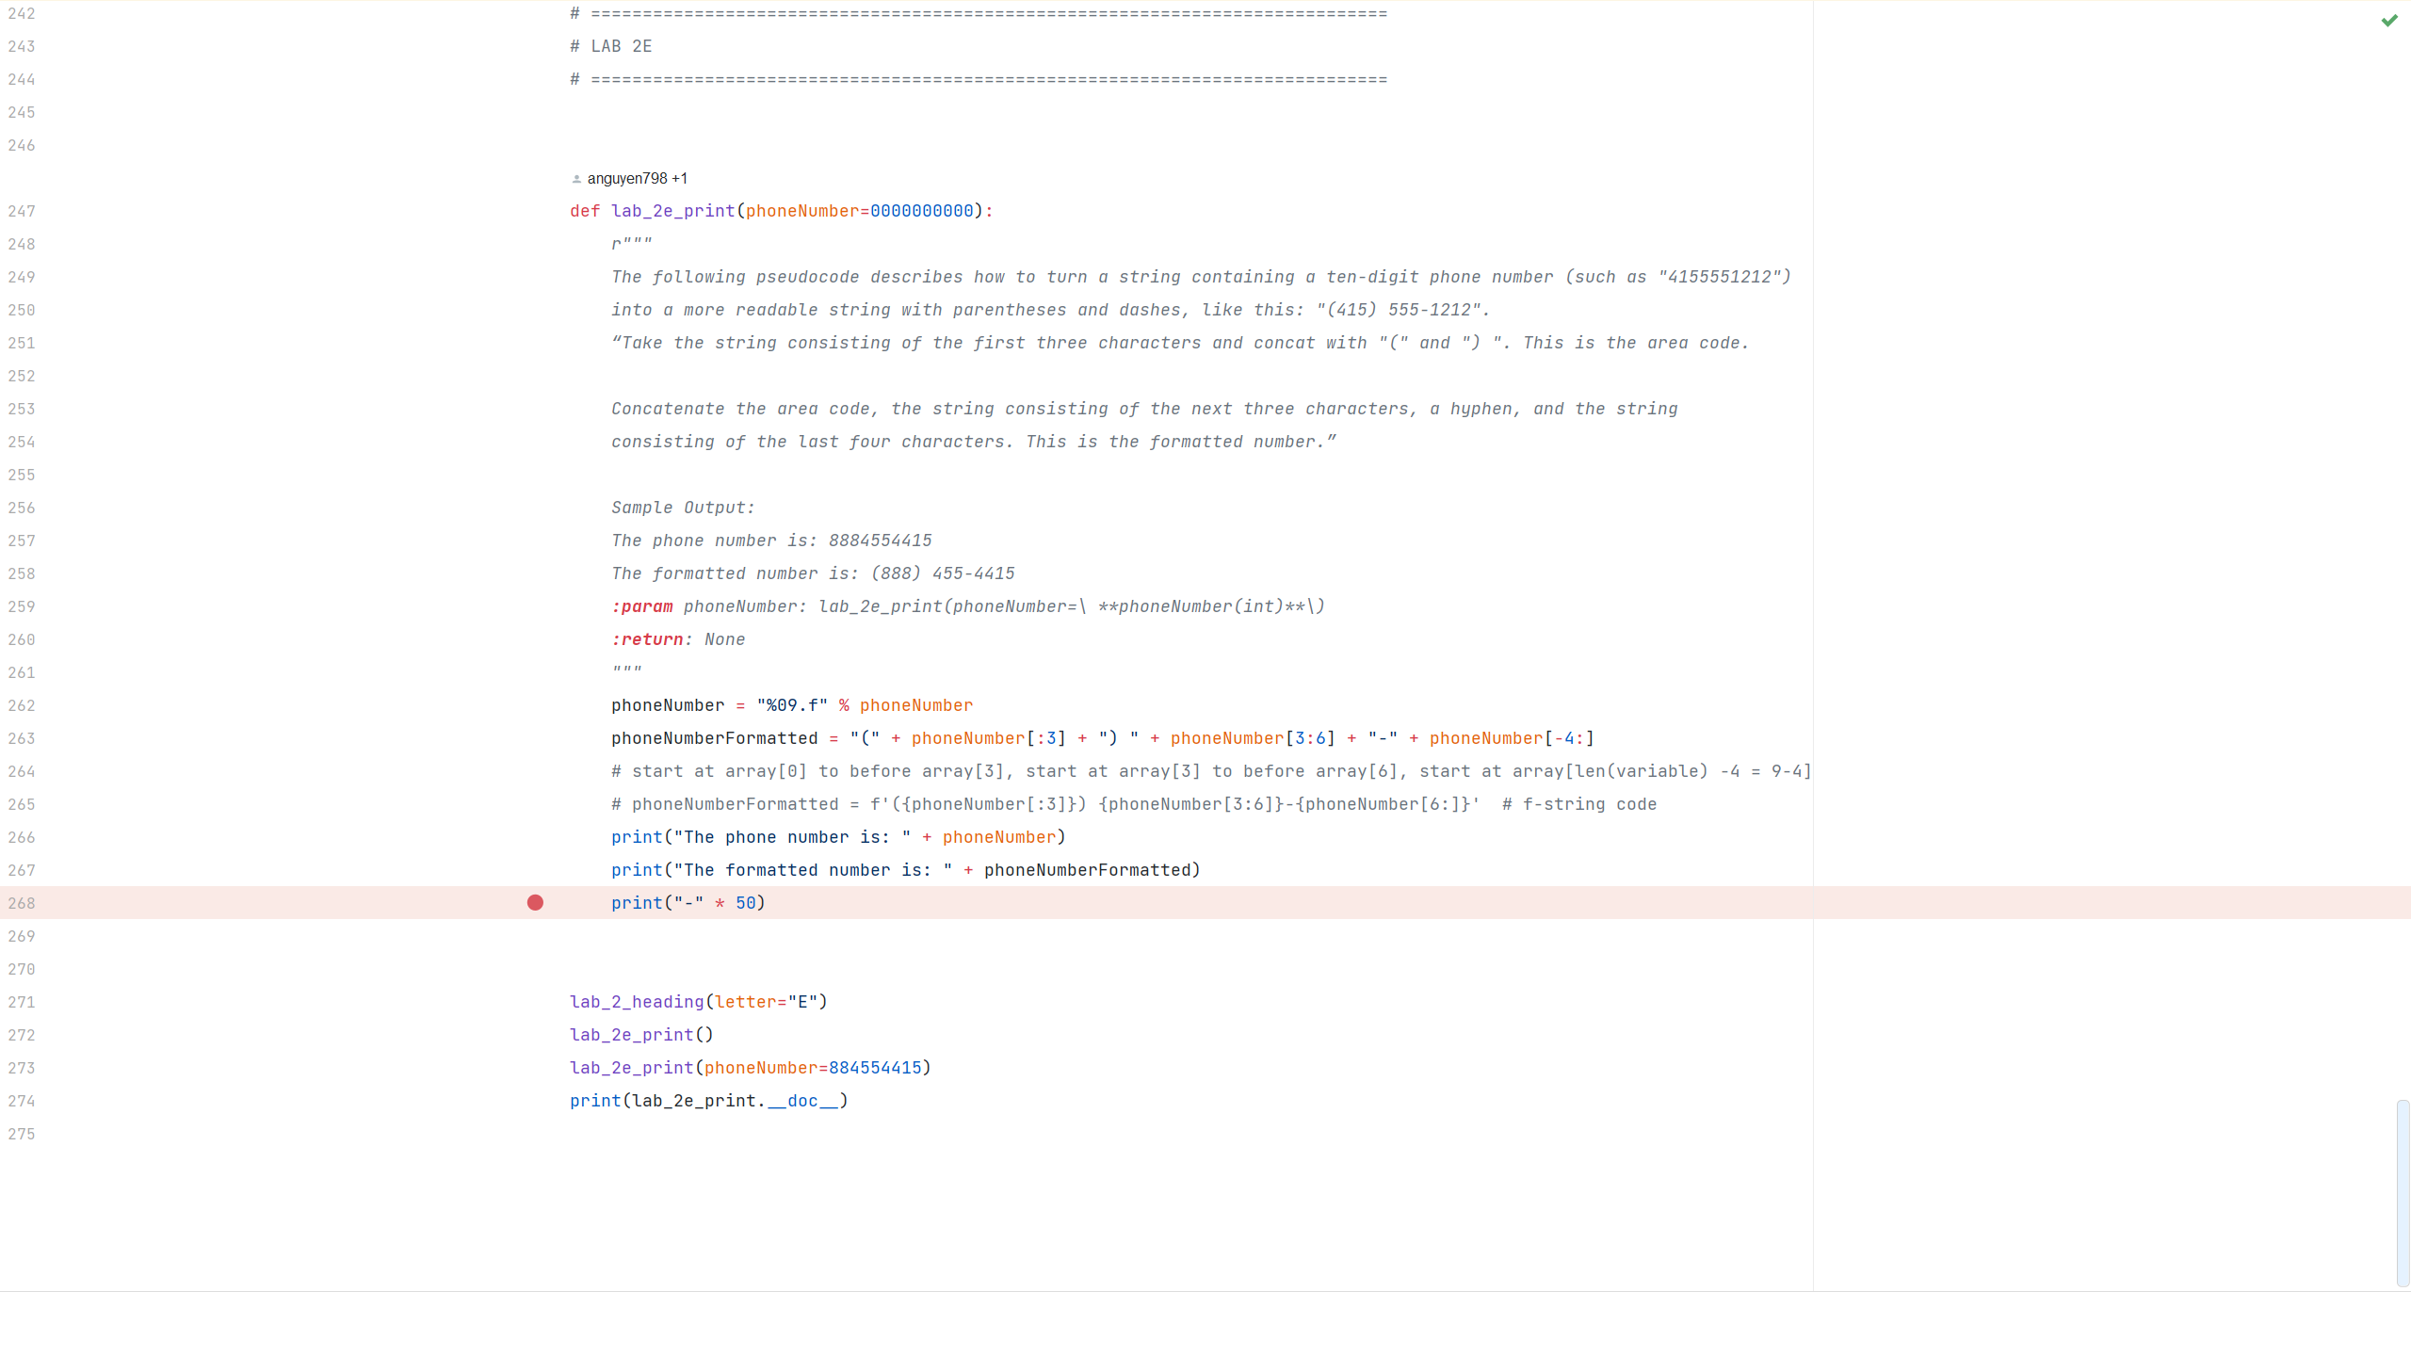

E_Code

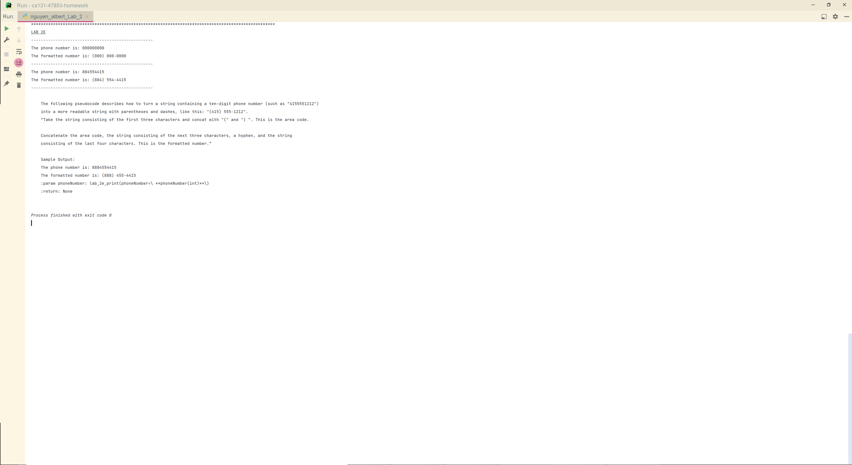

E_Console

Lab2 - Import and Heading function (adds separator, underlined heading and sub-separator); doc-strings included at end of output with exercise description and parameter details
A_Code - Soft drink cans and liter bottle capacity and comparison
A_Console - Soft drink cans and liter bottle capacity and comparison
B_Code - Two variables(int) with multiple math CONSTANTS
B_Console - Two variables(int) with multiple math formulas CONSTANTS
C_Code - Five variables(int) with three math formula CONSTANTS; passing function parameters into variables; import math
C_Console - Five variables(int) with three math formula CONSTANTS; passing function parameters into variables; import math
D_Code - Prompts, arrays, length function, string formatting; with while loop and exceptions to force user to input correct type
D_Console - Prompts, arrays, length function, string formatting; with while loop and exceptions to force user to input correct type
E_Code - String formatting with % operator and array[] indexes
E_Console - String formatting with % operator and array[] indexes

